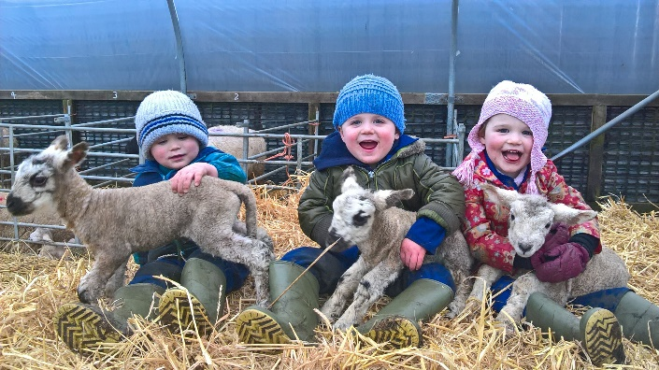**Farm School Exmoor**

Coombe Farm Partnership, Coombe Farm, Exford, Minehead, Somerset. TA24 7QQ.

01643 831237 / 07854 104913

[serenacolwill@hotmail.com](mailto:serenacolwill@hotmail.com)

Dear Parents/Guardians,

We are really looking forward to welcoming you onto our farm when you visit us with …

Farm school will be held at Coombe Farm, which is based just outside of Exford. Serena Colwill and Denise Stanbury, who are two farmers will teach your child/ren the links between farming, conservation and food production, using the land as a classroom.

You will be attending a session on …

We will be outside whatever the weather, so it is very important that you and your child/ren bring/wear appropriate clothing:

* Old clothes or a full set of waterproofs/ overalls which completely cover their school clothes. Legs and arms should be covered during all seasons to avoid tick bites.
* Clean welly boots
* Additional layers maybe needed and hopefully suncream!

It is recommended that your child’s name is on each of their items of clothing.

We have a risk assessment in place for farm visits and every necessary step will be taken to reduce any risk, the government have created a document called ‘avoiding infection on farm visits’. Please follow the link below or scan the QR code for further information. <https://assets.publishing.service.gov.uk/government/uploads/system/uploads/attachment_data/file/796824/Farm_visits_avoiding_infection.pdf>

Three main points from this document for you as a parent:

1. It is recommended that you wash your child/ren’s clothes after they have visited the farm
2. Washing hands thoroughly and correctly is paramount. Children will be taught at school

and on the farm how to do this, they will also be supervised, whilst washing their hands.

If you’d like to have a practise at home, please follow this link for step-by-step instructions and a video.

<https://www.nhs.uk/live-well/best-way-to-wash-your-hands/>

1. Finally, there is guidance on what you should do if your child feels unwell after a farm visit.

We are really looking forward to having an enjoyable and educational experience with your child/ren.

Your sincerely

Serena and Denise