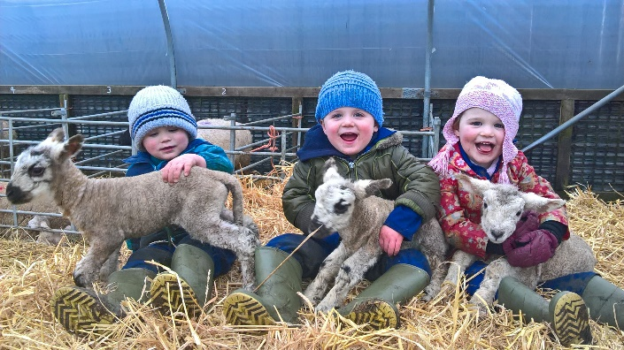**Farm School Exmoor**

Coombe Farm Partnership, Coombe Farm, Exford, Minehead, Somerset. TA24 7QQ.

01643 831237 / 07854 104913

[serenacolwill@hotmail.com](mailto:serenacolwill@hotmail.com)

Dear …

We are really looking forward to welcoming your group onto our farm.

Farm school will be led by Serena Colwill and Denise Stanbury, who are two farmers. They will teach your pupils links between farming, conservation and food production, using the land as a classroom.

Farm school will be held at Coombe Farm, which is based just outside of Exford. Our address can be found above, but please follow these directions from Exford- turn off the B3224 onto Park Street towards Porlock, take the next right, which is a no through road named Combe Lane, follow the hill up out of the village, we are the fourth entrance on the right. Our farm is only accessible via mini-bus; however, arrangements can be made for larger buses to drop off in the village.

Your main contact will be Serena, please contact her using the details found above.

If you have not visited us before and would like to organise a pre-visit, please do not hesitate to get in touch.

Your group will be attending a session on …

Before visiting us, it is really important that you inform us of any participant who has an allergy or additional need, please do this by emailing Serena at [serenacolwill@hotmail.com](mailto:serenacolwill@hotmail.com)

I will need you to complete the ‘photo consent’ form, which will be attached in the email I sent to you, please fill in the required information and email to Serena prior to your session.

Before your visit to our farm, please can you ensure that you review our risk assessment and map of the farm, as well as the access to farms codes of practise (<https://s3-eu-west-1.amazonaws.com/leaf-website/Teachers_Code_of_Practice.pdf>) , the documents contain important information about your visit, some of the key points which you will need to know beforehand are:

* Pregnant woman will not be permitted on the farm at any time.
* A maximum of ‘a class size’ per session are allowed, the school/group is responsible for ensuring the correct adult: child ratio is adhered to.
* It is the schools/groups responsibility to have the details of medical and first aid needs of children in their care. Cuts and grazes etc. on hands will be covered with a waterproof dressing.
* It is the schools/groups responsibility to ensure the correct number of designated first aiders are presents during the visit.
* Groups will be responsible for carrying their own fully stocked first aid kit, we suggest including a tick removing tool and antihistamines.
* It is the groups responsibility to carry a register with the contact details of each visitor.
* If the session involves tasting food, it is the groups responsibility to know the dietary requirements of each child in their care.
* We will be outside whatever the weather so appropriate clothing must be worn by everyone. Old clothes should be worn or overalls or waterproofs should completely cover school clothes or day to day clothes. It is recommended that long sleeved tops and trousers are worn all year round. Clean wellies must be worn by everyone. Please ensure suncream is applied on each child before arriving at the farm.
* It is the groups decision whether the children/adults in their care wear a florescent jacket during their visit.
* Please familiarise yourself with the document entitled ‘avoiding infection on farm visits’

<https://assets.publishing.service.gov.uk/government/uploads/system/uploads/attachment_data/file/796824/Farm_visits_avoiding_infection.pdf>

* It is advisable that water bottles and lunches are kept together, for example in a tray. Everyone must wash their hands before drinking/eating and a suitable area away from animals will be found for eating and drinking. If your group are bringing food to our farm, please let us know.
* In some severe weather conditions, we may have to cancel the session, therefore it is important that we have up to date contact information.

During your visit:

* On arrival to the farm, all of the group will stay on the mini bus until the leader has seen Serena/Denise (07854 104913 / 07807 245765)
* Before any activity, Serena and Denise will talk to the staff/children about the farm, ensuring they are fully aware of the plans for the session and highlighting key points in the risk assessment.
* It is very important that everyone listens to the leader throughout their session and the leader must know the whereabouts of each participant at all times.
* Group leaders are responsible for the behaviour of the children in their care.
* All visitors will be responsible for washing their hands correctly, it is advised that you practise this at school <https://www.nhs.uk/live-well/best-way-to-wash-your-hands>. If children/adults are taking their wellies off at school/home, everyone must wash their hands once the wellies are packed away.
* If a member of your group shows signs of illness (e.g., sickness or diarrhoea) after a visit, advise them or their parent/guardian to visit the doctor and explain that they have had recent contact with animals. Please also contact us to inform us of the illness.

We have created a letter, that you can send to your parents/carers, containing the information they need to know about farm school, please add group specific details to this letter.

Finally, to enable us to provide these visits fully funded we require the ‘Farm visit declaration form’ to be filled in after every session. Please find this form attached, the leader of the visiting group should fill in section B and C. We also require the ‘evaluation form’ to be completed.

We are really looking forward to having an enjoyable and educational experience with your group.

Kind regards

Serena and Denise