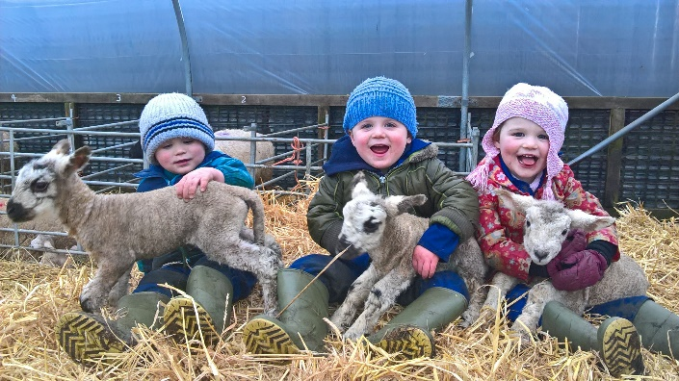 **Farm School**

Coombe Farm Partnership, Coombe Farm, Exford, Minehead,

Somerset. TA24 7QQ.

01643 831237 / 07854 104913

[serenacolwill@hotmail.com](mailto:serenacolwill@hotmail.com)

**Evaluation Form**

**School/group name: ……………………………………………………………………………………………….**

**Date of visit: ………………………………………………………………….**

**Lesson/ objectives: …………………………………………………………………**

**Age of group (please circle):**

Pre-school KS1 KS2 KS3 KS4 College Adults

**Number of attendees:**

1 – 6 people 7 – 12 13 – 18 19 – 24 25 – 32 32+

**Our group was provided with everything we required before our visit:**

Strongly agree Agree Neutral Disagree Strongly disagree

**It was easy to find ‘Farm School’:**

Strongly agree Agree Neutral Disagree Strongly disagree

**The access to ‘Farm School’ was good:**

Strongly agree Agree Neutral Disagree Strongly disagree

**The facilities at ‘Farm School’ provided everything that our group needed:**

Strongly agree Agree Neutral Disagree Strongly disagree

**Whilst on the farm, safety was paramount:**

Strongly agree Agree Neutral Disagree Strongly disagree

**Our visit covered all of the objectives our group requested and was age appropriate:**

Strongly agree Agree Neutral Disagree Strongly disagree

**The activities organised by ‘Farm School’ worked well and everyone enjoyed their visit:**

Strongly agree Agree Neutral Disagree Strongly disagree

**The time for each activity was well allocated and the session was to time:**

Strongly agree Agree Neutral Disagree Strongly disagree

**How did you hear about ‘Farm School’?**

Communication from ‘Farm School’ Recommendation from another school/ group Social media

Website Other: ……………………………………………………………………

**Would you recommend ‘Farm School’?**

Yes Neutral No

**So that we can provide an amazing experience for all our visitors we would be very grateful if you could provide any additional comments, such as your favourite parts of the session and areas we could improve on:** ……………………………………………………………………………………………………

………………………………………………………………………………………………………………………………………………………………………………………………………………………………………………………………………………………………..

**I give my permission on behalf of the group to Coombe Farm Partnership (Farm School) to collect, handle and store the information on this form and the details on the ‘Farm Visit Declaration Form’. The information on these two forms will be used by Coombe Farm Partnership (Farm School) only, and for such purposes as data collection for grant applications or to market the business further.**

Yes No